German-Russian Institute of Advanced Technologies

TU-Ilmenau(Germany) and KNTRU-KAI(Kazan, Russia)

**Laboratory research №4**

**“Stability region construction in one parameter plane”**

                                Student: Kukarcev KS, 4167

                                Lecturer:________________

Kazan 2018

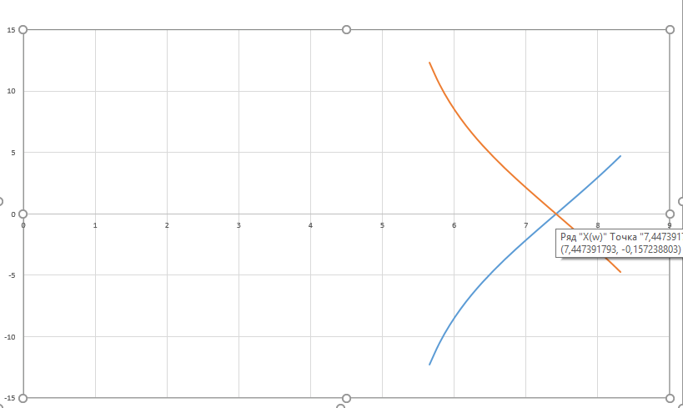

|  |  |  |
| --- | --- | --- |
| w | X(w) | Y(w) |
| -1,11 | 8,311948 | 4,721758208 |
| -1,07 | 8,202667 | 4,10395627 |
| -1,03 | 8,088651 | 3,476941175 |
| -0,99 | 7,96985 | 2,839646457 |
| -0,95 | 7,846255 | 2,190784287 |
| -0,91 | 7,717904 | 1,528786995 |
| -0,87 | 7,584894 | 0,85173121 |
| -0,83 | 7,447392 | 0,157238803 |
| -0,79 | 7,305646 | -0,557653423 |
| -0,75 | 7,16 | -1,296666667 |
| -0,71 | 7,010904 | -2,064512015 |
| -0,67 | 6,858927 | -2,867205167 |
| -0,63 | 6,704775 | -3,712499776 |
| -0,59 | 6,549292 | -4,61049423 |
| -0,55 | 6,393474 | -5,574498342 |
| -0,51 | 6,238473 | -6,622300269 |
| -0,47 | 6,085593 | -7,778069352 |
| -0,43 | 5,936282 | -9,075305913 |
| -0,39 | 5,792119 | -10,56158651 |
| -0,35 | 5,654788 | -12,30653834 |
| 0,35 | 5,654788 | 12,30653834 |
| 0,39 | 5,792119 | 10,56158651 |
| 0,43 | 5,936282 | 9,075305913 |
| 0,47 | 6,085593 | 7,778069352 |
| 0,51 | 6,238473 | 6,622300269 |
| 0,55 | 6,393474 | 5,574498342 |
| 0,59 | 6,549292 | 4,61049423 |
| 0,63 | 6,704775 | 3,712499776 |
| 0,67 | 6,858927 | 2,867205167 |
| 0,71 | 7,010904 | 2,064512015 |
| 0,75 | 7,16 | 1,296666667 |
| 0,79 | 7,305646 | 0,557653423 |
| 0,83 | 7,447392 | -0,157238803 |
| 0,87 | 7,584894 | -0,85173121 |
| 0,91 | 7,717904 | -1,528786995 |
| 0,95 | 7,846255 | -2,190784287 |
| 0,99 | 7,96985 | -2,839646457 |
| 1,03 | 8,088651 | -3,476941175 |
| 1,07 | 8,202667 | -4,10395627 |
| 1,11 | 8,311948 | -4,721758208 |